**Historical Climatic & War Events in Ethiopia**

The following events in Ethiopian history are well documented and align with periods when tree-ring growth might register suppressed growth (negative z-scores). For each event I describe what happened, where, causes, and why it should show up in tree-ring data.

1. **1958 Tigray Famine (~1957-1958)** [Link](https://en.wikipedia.org/wiki/1958_Tigray_famine?)  
   In the late 1950s, especially 1957-1958, a severe famine struck Tigray and parts of Wollo provinces during the reign of Emperor Haile Selassie. The triggers included successive droughts, locust invasions, and neglect of agricultural infrastructure. Up to 100,000 people died.

**Possible Relation to tree-rings***:* Because tree growth is sensitive to moisture and season length, this period should show as a negative anomaly in the z-score. If your sample includes trees from Tigray or nearby highlands with good preservation, you might expect a dip in growth around 1957-1958.

1. **1972-1975 Wollo Famine** [Link](https://en.wikipedia.org/wiki/1972%E2%80%931975_Wollo_famine?)  
   Between 1972 and 1975, particularly in Wollo province and surrounding arid highland regions, Ethiopia experienced a prolonged famine. Crop failures due to rainfall deficit, poor governmental response, and socio-economic weakness greatly exacerbated the crisis. Some sources estimate the death toll between 40,000-80,000, though other estimates go higher.

**Possible Relation to tree-rings***:* A multi-year depressed growth is likely visible in this period. Because the drought impact lasted several years, tree rings from 1972-75 should show lower ring widths, possibly a sustained negative z-score trend.

1. **1983-1985 (1984) Ethiopian Famine** [Link](https://en.wikipedia.org/wiki/1983%E2%80%931985_famine_in_Ethiopia?)  
   One of the most catastrophic famines in Ethiopia’s recent history affected northern provinces (Tigray, Wollo, Begemder, Eritrea). It was caused by a combination of political instability, civil conflict, failed rains (both Belg and Meher seasons), and other stressors. Estimated death toll ranges from hundreds of thousands up to ~1.2 million.

**Possible Relation to tree-rings***:* Because of the severity and breadth of this famine, one expects very pronounced negative anomalies around 1983-1985. Multiple cores in affected provinces should show growth suppression, negative z-scores, perhaps even the lowest values in the dataset, especially in those drought years.

1. **2015-2016 Drought (El Niño-associated)** [Link](https://www.worldweatherattribution.org/ethiopia-drought-2015/)  
   In 2015, Ethiopia suffered one of its worst droughts in decades. The drought was aggravated by a strong El Niño event. The Belg rains (Feb-May) were delayed or deficient; Kiremt season (June-September) rains were erratic and stopped early. Nearly 10 million people in the north and central regions were severely affected; many farmers lost crops and livestock.

**Possible Relation to tree-rings***:* In trees from central or northern Ethiopia, the years 2015 and 2016 should show negative z-score anomalies if growth was limited by moisture. Growth rings might be narrower. Because this is recent, preservation and dating should be good, giving a clearer signal.

**General Sources used:**

Famines in Ethiopia: [Source](https://en.wikipedia.org/wiki/Famines_in_Ethiopia?)

Drought in Ethiopia: [Source](https://civil-protection-humanitarian-aid.ec.europa.eu/news-stories/stories/ethiopia-worst-drought-generation_en?)

War Effects in Ethiopia: [Source](https://www.tandfonline.com/doi/full/10.1080/23311932.2023.2247696?)

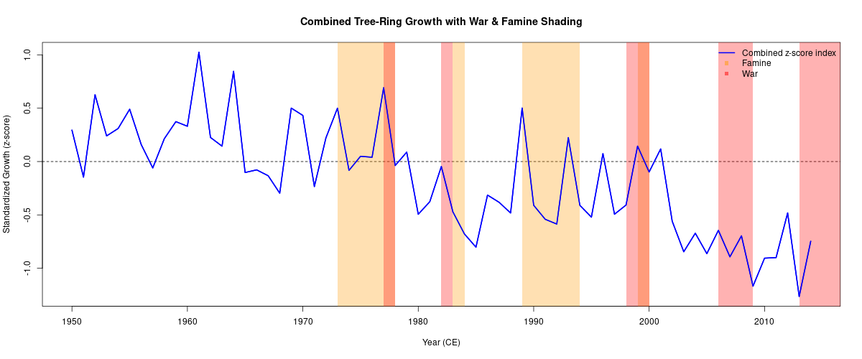

**Relation of These Events to the Z-Score Graph**

When comparing your combined tree-ring Z-score graph over years with the shading of famines and war, here are how they likely align:

* **~1957-1958**: A drop in growth (negative z-score) should align with the 1958 Tigray famine. If the graph shows a dip here, that supports the drought/famine link.

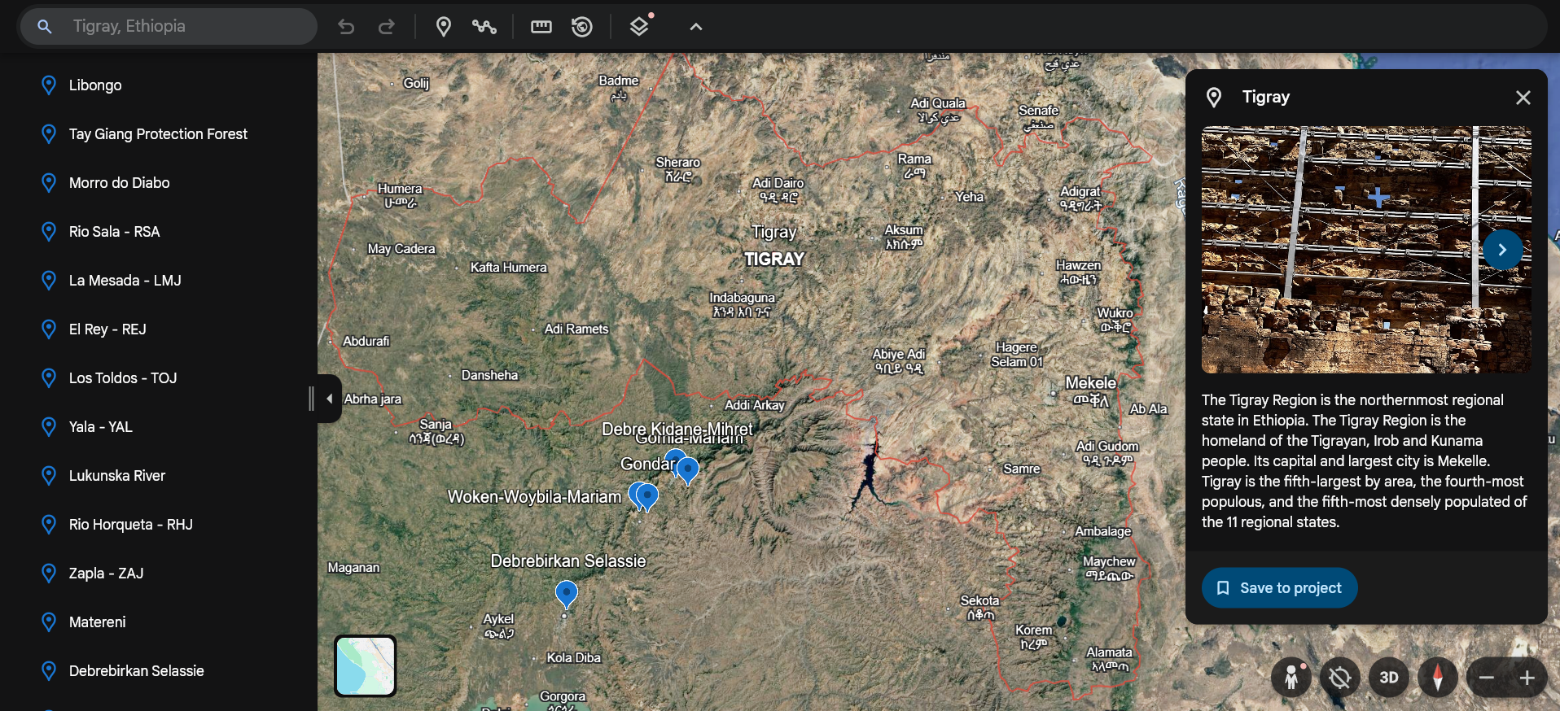

Nearest Data Region: Gomia-Mariam(eth002), Gondar(eth007)

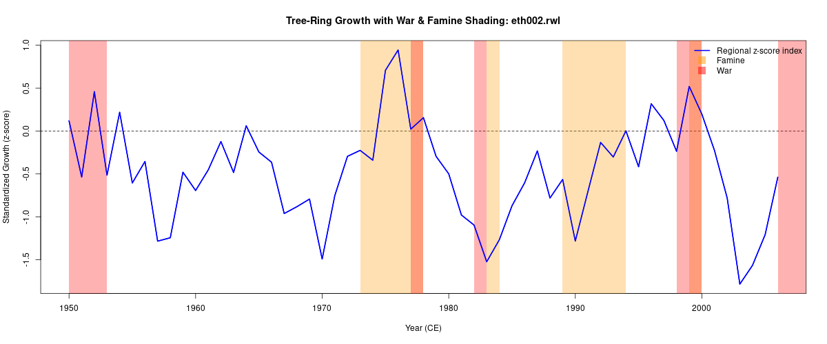

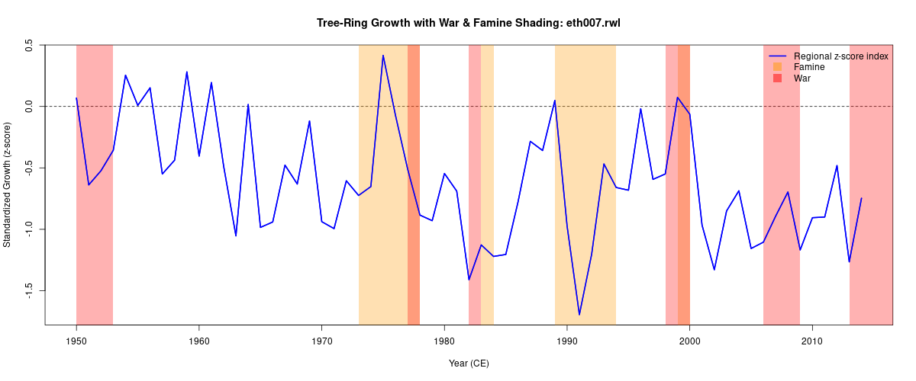

* **Early 1970s (~1972-1975)**: Expect a sustained lower growth or negative trend, matching the Wollo famine period; if the graph shading covers this period, one should see depressed z-scores.

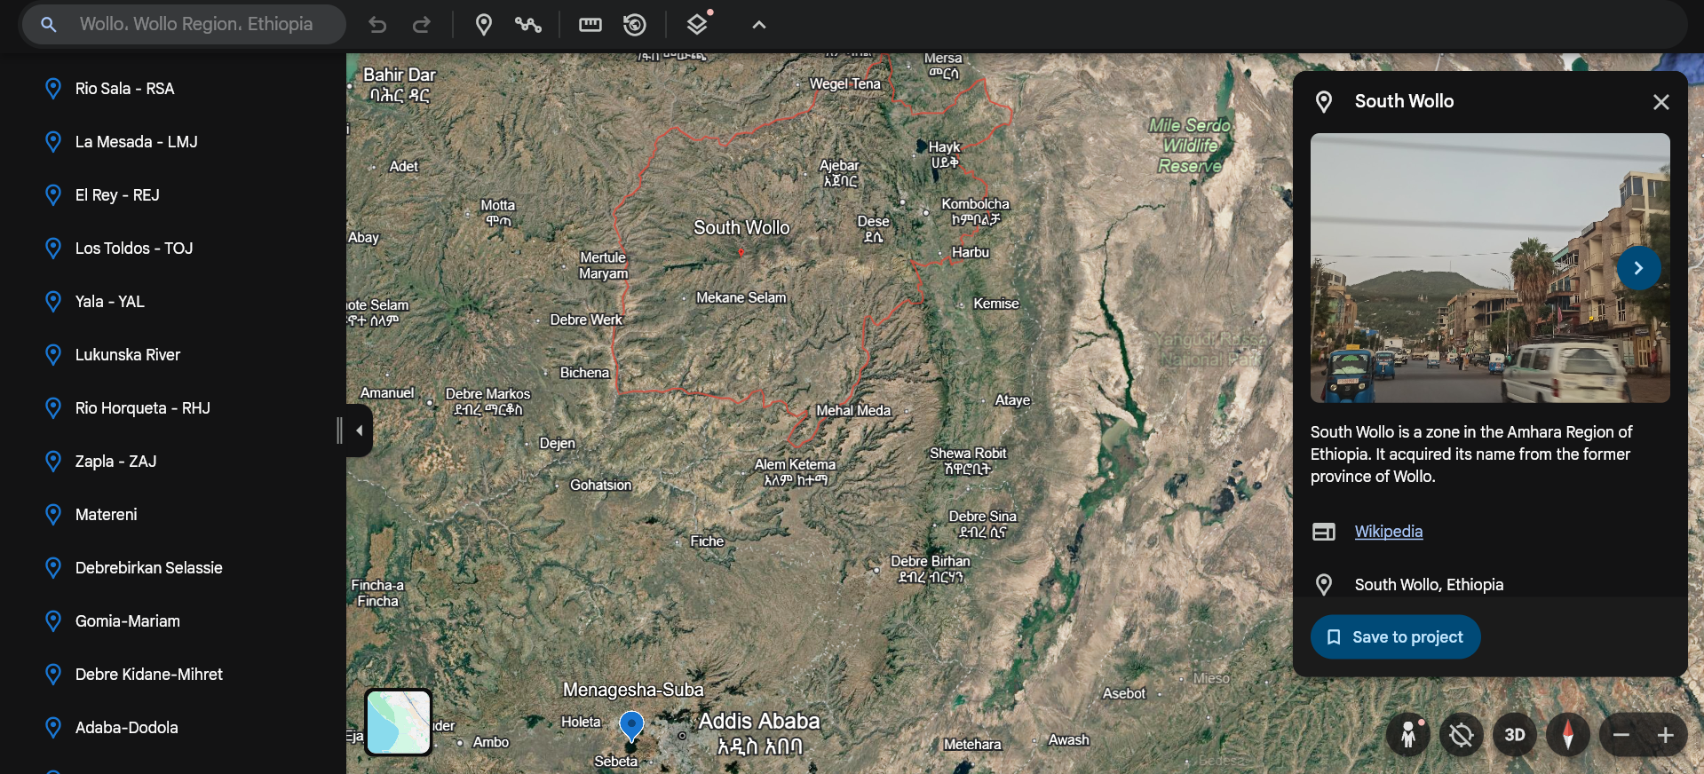

Nearest Data Region: Menagesha Suba (eth005)

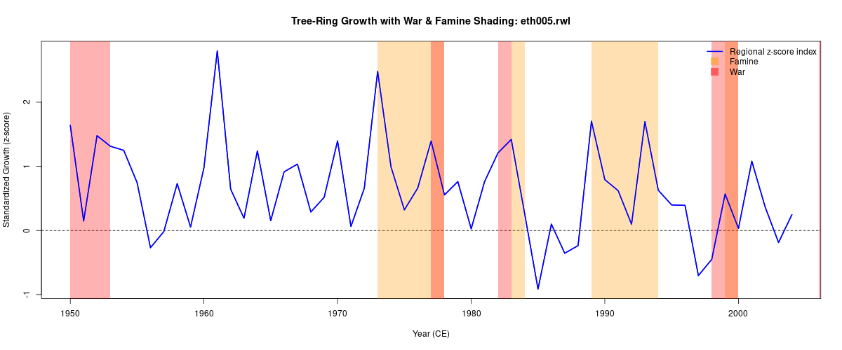

* **Early-Mid 1980s (1983-1985)**: Probably one of the deepest valleys in your graph during this span. The famine here was severe, so tree-rings should show among the lowest growth values.
* **2015-2016**: Look for a negative anomaly in those years. Even if the shading is war or famine, but drought is a strong component. If there’s a dip here, it provides strong recent evidence as well.